Break and Fix
- Failure created
Sudo systemctl stop nginx
- Systemctl status nginx -> The output shows server is inactive(dead)
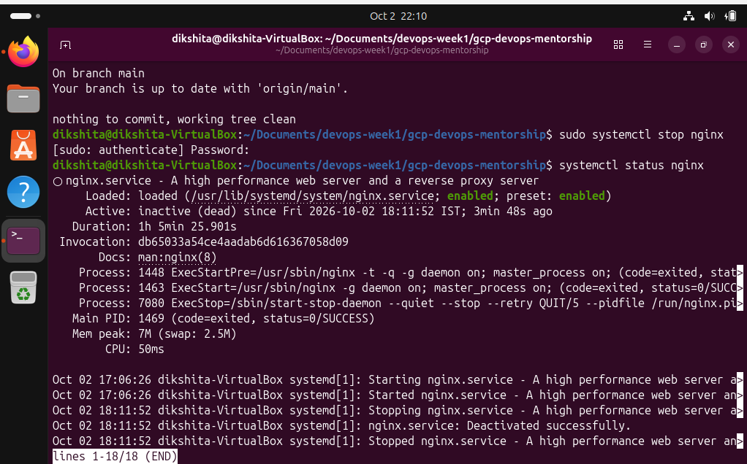

- Application failure
Curl http://localhost

- Check the port ss -tulnp
Because Nginx is stopped , port 80 is absent

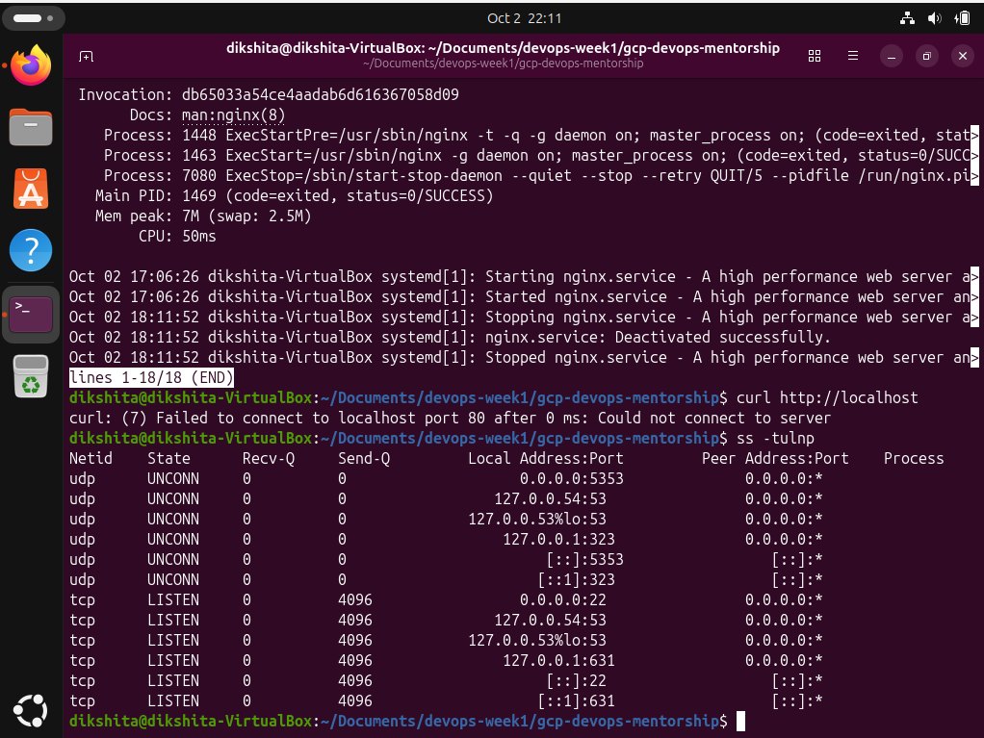

Nginx stopped -> Service inactive -> port 80 is not listening -> Curl cant reach the server.

- Fix the problem

Sudo systemctl start nginx

Now check running status

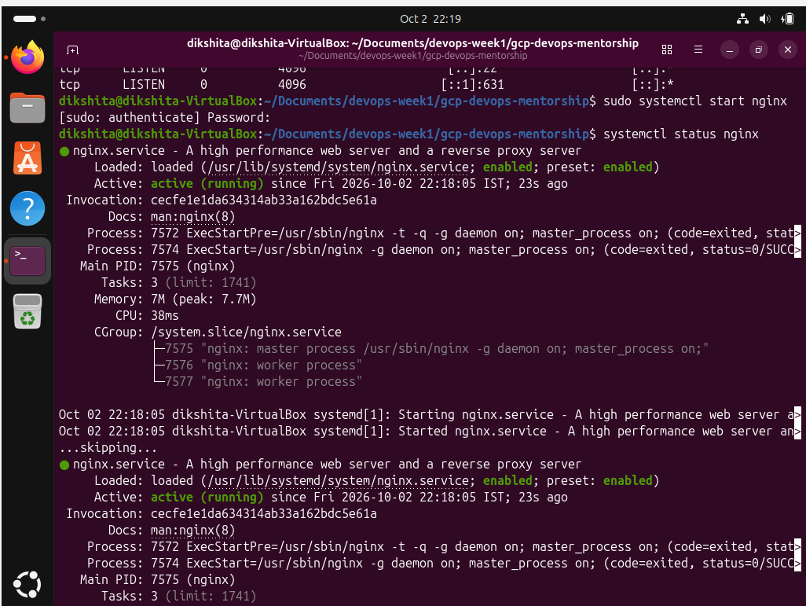

ss – tulnp
Port 80 is listening and present
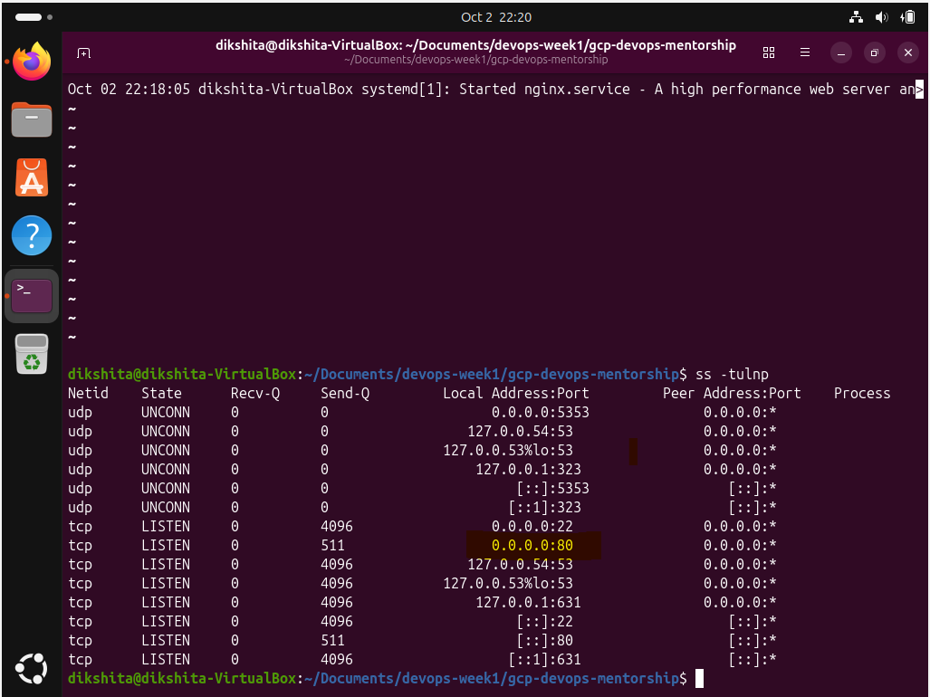

Curl http://localhost – returning the server

